

LIMITED

LIABILITY COMPANY

**LASERTAG**

SPECIFICATION

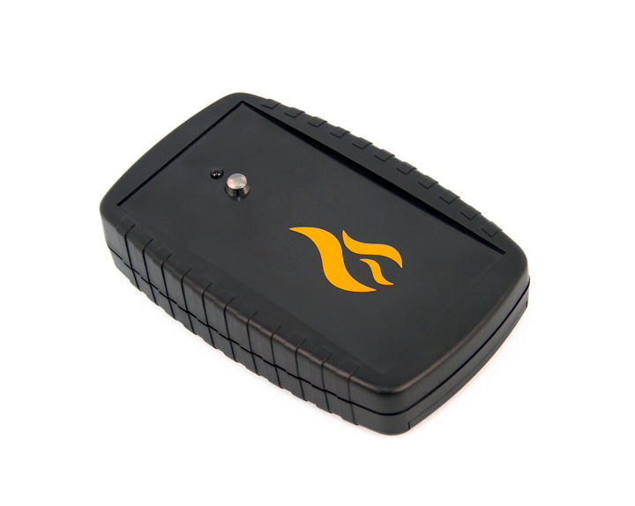

**Game set**

**Artifact**

Smolensk

In addition, during use of headbands, the device can experience mechanical damage to the caps that protect the sensors. In such cases, the caps must be replaced. It is necessary to recharge headbands immediately, no longer than 80 minutes after the game.

It is necessary to store the equipment in a well-ventilated space at temperature from + 18°C to + 30°C and relative humidity of 45-65%.

**Store equipment only in charged state (ideally under nominal voltage conditions).**

1. **Guarantee commitment**

The manufacturer guarantees the reliability of the operation of an individual LASERWAR set if the consumer has complied with the conditions of use. The manufacturer undertakes to replace or repair an individual set of equipment free of charge, if the customer has complied with the rules for the device transportation, storage, operation and delivery of defective equipment to Smolensk City.

**The warranty is 14 days for batteries, speakers, and IR modules.**

**PLEASE NOTE! In the case of improper operation of the accumulator (charging by an unrelated type of a charger), the warranty doesn't cover the battery!**

You can see on our website a complete technical maintenance manual for laser tag equipment: **www.cybertag.ru**.

1. **Operating rules**

***1. Weather conditions.*** We strongly recommend that the equipment shouldn’t be used in the rain and at temperatures below -20 ° C.

Avoid getting moisture inside the device. If this happened, turn off the device, dry the equipment at room temperature for at least two hours.

Having used the device at low temperatures don't try to charge it immediately after the game. Wait for electronics to warm up.

***2. Batteries.*** Lithium accumulators are used as a power source in the Artefact game set. Replace the batteries in time to ensure the good work of the device.

***3. Headband*** When using headbands pay attention to hygienic cuffs. They will protect electronic parts from moisture. If the bandage gets wet, it can result in the electronics failure. That's why the bandage should be dried.

6

7

1. **Description and work**
   1. **Device**

The Artefact game set has a black plastic frame.

Inside the frame there are batteries, clamping elements. On top of the frame you can see IR-diodes. There is also a photosensor which receives a signal from laser tag equipment.

The Artifact game set is designed to create radiation, anomaly zones as well as recover health points.

* 1. **Changing the performance characteristics**

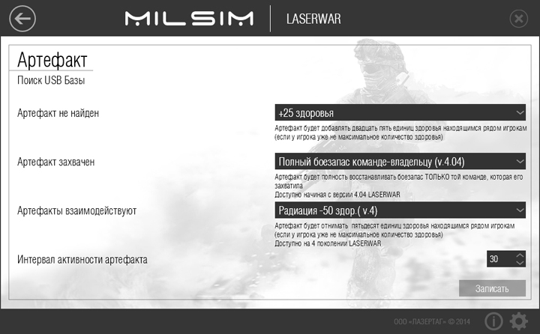

Information on the repairs performed during the maintenance period (completed by the Service centre performing the warranty repair works).

|  |  |
| --- | --- |
| **Date**: __________________  **Completed work:** _____________________________________________________________________  **Service centre stamp** | **Date**: __________________  **Completed work:** _____________________________________________________________________  **Service centre stamp** |
| **Date**: __________________  **Completed work:** _____________________________________________________________________  **Service centre stamp** | **Date**: __________________  **Completed work:** _____________________________________________________________________  **Service centre stamp** |
| **Date**: __________________  **Completed work:** _____________________________________________________________________  **Service centre stamp** | **Date**: __________________  **Completed work:** _____________________________________________________________________  **Service centre stamp** |

3

10

Connect a USB base to your PC to run the programming mode. Then open Lasertag Configurator.

**You can't programme several devices at a time!** To run the programming mode, hold the tact switch on the front lid and turn on the device. The LED will turn pink. Then you must select the IR commands for each of the artifact modes, the time between the activity, and click the "Write" button.

* 1. **Pre-starting procedure**

You can turn on the Artifact game set by pressing a button located on the battery compartment.

Each artifact has three operation modes:

1. Standby (artifact not found).

2. Captured (artifact captured).

3. United (artifacts interact with each other).

**Standby mode**

Once enabled, the artifact is in standby mode. The diode will turn white every ten seconds (the number of flashes corresponds to the artifact type). You will also hear a Geiger counter - like sound.

**Capture mode**

You can capture the artifact working in standby mode if you shoot at it. The LED will light up the color of the team that has captured it. Every second you will hear sound clicks. If the player of the opposing team shoots at the device the artifact will start working in standby mode.

Warranty Terms:

1. The guarantee is effective upon presentation of the present certificate, which indicates the purchase date of the equipment confirmed by the service centre.

2. These guarantee obligations apply to products acquired only from the official LASERTAG representative or the official dealer.

3. The present guarantee is invalid if the product deficiencies have occurred in the following cases:

- failure to comply with Operating instructions;

- mechanical damage;

- penetration of extraneous items, liquids, etc.;

- animal activities;

- unauthorized access to the parts of the game set by non-authorized persons;

- use of the product for purposes for which it hasn't been made;

- Acts of elements (natural disaster, fire, accidents, etc.);

- the game set malfunction in case of faulty power network and/or poor care of the product.

4. If the warranty certificate is lost, no duplicate is issued.

4

9



Dear Customer!

Our company welcomes and thanks you for the decision to buy our products, and is confident that the purchased device will bring you a long-term pleasure. The warranty certificate establishes the guarantee of the product in the amount provided for by the Law on consumer protection of the Russian Federation.

This warranty certificate is valid for **12 months** from the purchase date of the product, and is subject to the guarantee terms.

**United mode.**

To run this mode several conditions must be met.

- Artifacts must be of different types. The same artifacts do not interact with each other;

- Artifacts must be captured by one and the same team.

- Artifacts must be adjacent to each other, there should be no obstacles between them.

It takes 5-10 seconds for devices to be united. After that, the artifacts will start blinking. The LEDs color will light up the color of the team that controls the devices. If an opponent is captured by a united artifact, the artifacts will run the standby mode, they'll have to be recaptured. If one of the united artifacts is out of the reach of another artifact, , the connection between the artifacts will be lost within 10-20 seconds. The devices will run the capture mode.

In each mode, at certain intervals (programmed through the computer), the artifact sends an IR command that corresponds to a particular mode. The activity interval is between 10 seconds and 3 minutes.

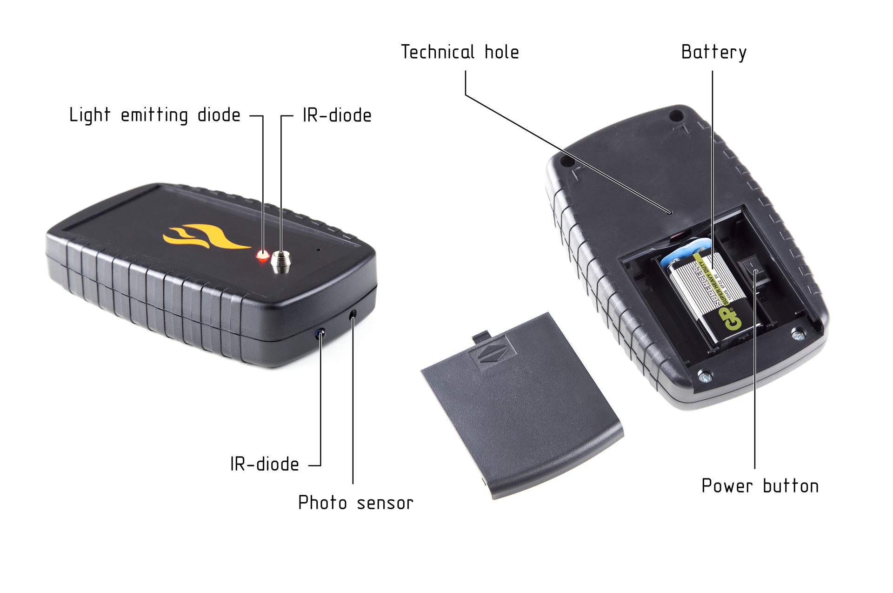

8

5

Purchase Date: _______________

1. **Contact information**

Official website:

www.laserwar.ru

E-mail:

info@laserwar.ru

support@laserwar.ru

Skype:

info-laserwar.ru

support laserwar.ru



**_____________________**

*Stamp signature*

1. **The intent of the device**

The Artifact game set is an additional device designed to play laser tag.

1. **Technical Specifications**

|  |  |
| --- | --- |
| Weight | 0.19 kg |
| Dimensions | 145 x 90 x 33 mm |
| Power source type | "Krona";  9 V |
| Battery life | Up to 3 months |

1. **Contents of delivery**

|  |  |  |  |
| --- | --- | --- | --- |
| **No.**  **Ser. No.** | **Name** | **Unit of Measure** | **Amount** |
| 1. | Artifact | pc. | 1 |
| 2. | SPECEFICATION | pc. | 1 |

11

2